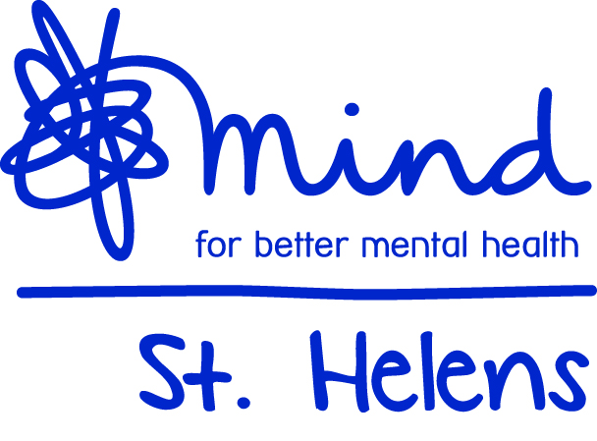
Registered Office: St Helens Mind, Room G66, Harry Blackman House
Peasley Cross Hospital, Marshalls Cross Road, St Helens, WA9 3DR
Telephone No. 01744 647089 Email. admin@sthelensmind.org.uk
www.sthelensmind.org.uk

St Helens Mind is registered in England and Wales
as a Registered Charity No. 1143292 and Company Limited by Guarantee No. 7659498

Befrienders and Group Volunteers Information Sheet

St.Helens Mind is a voluntary organisation working with people who live in the Borough, are aged 18+ and who experience distress or isolation because of mental health difficulties. Volunteers can be involved in a variety of ways: They can be Befriending Volunteers, Allotment Volunteers or Groups Volunteers

The Befriending Service

The Befriending Service will provide support for people who feel isolated or alone because of the effects of mental illness.

We are always seeking new Volunteer Befrienders. Is this you?
Have some free time?
Enjoy meeting people?
Interested in helping someone who is isolated due to mental health difficulties?

What is a Befriender and how can you help someone?
A Befriender is a person who can be there for someone; to listen to them and give them some time when it is most needed.

As a Befriender you could help someone in many ways. For example:
- Visit someone at home
- Go shopping with them
- Visit the doctor or go to other appointments
- Help to find information about local clubs, groups etc.
- Accompany your Befriendee on new ventures, such as clubs or classes, for the first time
- Support them during a difficult period

In return for your time and emotional support, to a person who really needs your friendship, we will provide training, support, guidance and expenses to cover travel and social activities.

Allotment Volunteers
St.Helens Mind has a flourishing Allotment and urgently needs volunteers to help support people with mental health difficulties who use the allotment. You do not need to be an expert gardener, just be willing to help and enable other people to benefit from some fresh air, exercise, peace or company.

Group Volunteers
St.Helens Mind has 8 social groups across the Borough. The groups provide a safe and welcoming environment for people to enjoy the company of other people for a couple of hours a week. Some groups are mixed, with some just for men and some just for women. They enjoy various activities and help to provide a social environment for people who are isolated due to mental health difficulties.

Volunteers help to make the visit enjoyable and welcoming by offering support, ensuring people feel welcome and safe, and maybe encouraging them to join in activities. You would also be expected to help refreshments and setting up the rooms.

How to apply to be a volunteer – please see overleaf:

St.Helens Mind Volunteers need to complete an application form, provide two references, attend an induction session and have a CRB (Police Check) that we do from the St.Helens Mind office.

Registered Office:- St.Helens Mind, Room G68, Harry Blackman House,
Peasley Cross Hospital, Marshalls Cross Road, St Helens WA9 3DR

Telephone: 01744 647089 Email address: sthelmind@yahoo.com
Website: www.sthelensmind.org.uk

Mission Statement

St.Helens Mind is an independent, user focused organisation providing quality services for local people who are experiencing isolation and distress due to mental ill health. We will do this by:

Providing a range of services appropriate to the needs of people experiencing mental distress that enhances their self-worth as valued citizens.

Promoting increased awareness and understanding of mental health issues within the community

Aims and Objectives

St.Helens Mind aims to promote and preserve good mental health and to assist those experiencing mental distress to regain their full potential.

Our aim is to support people aged 18+ who are experiencing mental difficulties in St.Helens Borough so they achieve their full potential and play and active part in community life.

Vision and Values

Our vision is that there will be no stigma surrounding mental ill health, and for people experiencing mental difficulties to automatically have access to appropriate, timely, unlimited and effective support. We aim to improve the lifestyles of people living in St.Helens Borough regardless of their cultural, religious and lifestyle needs.

Our services are non-judgemental and offer opportunities to develop self-esteem and confidence by encouraging and supporting involvement.

Quality

We are affiliated to Mind and are committed to their quality management programme (Quality Management in Mind (QMIM)
St.Helens Mind is committed to achieving high quality in the provision of services for people with mental health needs within the following principles:

- To strive for continuous improvement in all that we do.

- To use recognised / agreed standards as a means of continuous improvement and not as ends in themselves

- To agree quality requirements with commissioners and service users and to try to adhere to these at all times

- To work in the best interests of our service users at all times

COMPANY NO: 7659498 * CHARITY REG. NO: 1143292

