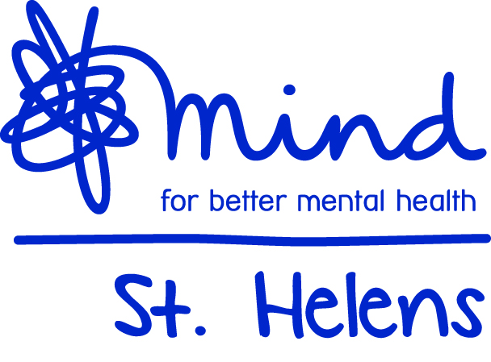
Registered Office: St Helens Mind, Room G66, Harry Blackman House
Peasley Cross Hospital, Marshalls Cross Road, St Helens, WA9 3DR
Telephone No. 01744 647089 Email. admin@sthelensmind.org.uk
www.sthelensmind.org.uk
St Helens Mind is registered in England and Wales
as a Registered Charity No. 1143292 and Company Limited by Guarantee No. 7659498

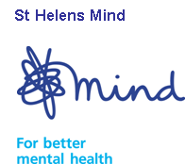
St.Helens Mind Social Groups Information Sheet

St.Helens Mind is a voluntary organisation supporting Groups for people who are experiencing mental health problems and who would benefit from an enjoyable, safe and welcoming place to meet with others.
People who attend the Mind social groups come from all backgrounds, all walks of life and have many interests and experiences. If you are aged 18+ and experience mental health difficulties and feel you would benefit from joining one of the groups please contact us to find out more.
We can arrange for you to visit the group of your choice and see if you would enjoy it. After a couple of visits you would have the option to be referred to the group or refer yourself. You would then be able to attend regularly. At the groups, people can enjoy discussions, quiet time to read, board games, cards, dominoes, guest speakers and information sessions, occasional days out and evening meals, making friends and socialising. We provide light refreshments at a small charge and the opportunity to be part of planning ahead for the group.
Groups aim to:

- Provide a place to go for company and mutual support
- Build confidence and self-esteem
- Give you the opportunity to contribute skills and experience
- Support recovery
- Provide support to access mainstream opportunities
- Develop social skills
- Lessen isolation

Making a referral:
St.Helens Mind accepts referrals to Groups from individuals, health professionals, family, or other support workers. We welcome referrals from people who have become isolated or who are experiencing difficulties due to their mental health problems and would benefit from the support of a social group.
We cannot accept referrals for:
- People who pose a threat or danger to others, and are actively using illicit substances or
abusing alcohol.
- People who need more specific intervention than St.Helens Mind can offer.

Men’s Group,  The Mansion House, Victoria Park,  North Road, Monday 9.30 - 12.30 noon  Tuesday Social Group (Mixed)  Mansion House, Victoria Park, North Road.  Tuesday 1.00pm – 3:00pm  And/or Friday 1:00 – 3:00pm  O’Connell Close, Haydock  Wednesday 1.00 - 3.00  Ladies Active Group – dates and times vary | Ladies Creative Group  Thatto Heath Library, Thatto Heath Rd.  Monday 1:30 – 3:30  Allotment Group, Off Hard Lane, St.Helens  Various times and days  Crownway Group, Crownway Community Centre, Newton-le-Willows. Fridays 1.00 - 3.00  Social Evening, Last Wednesday of every month. 5.30 – 7.30 Venue Varies  Mansion House Gardening Group:  Tuesday & Fridays 1:00 – 3:00pm
Mission Statement

St.Helens Mind is an independent, user focused organisation providing quality services for local people who are experiencing isolation and distress due to mental ill health. We will do this by:

Providing a range of services appropriate to the needs of people experiencing mental distress that enhances their self-worth as valued citizens.

Promoting increased awareness and understanding of mental health issues within the community

Aims and Objectives

St.Helens Mind aims to promote and preserve good mental health and to assist those experiencing mental distress to regain their full potential.

Our aim is to support people aged 18+ who are experiencing mental difficulties in St.Helens Borough so they achieve their full potential and play and active part in community life.

Vision and Values

Our vision is that there will be no stigma surrounding mental ill health, and for people experiencing mental difficulties to automatically have access to appropriate, timely, unlimited and effective support. We aim to improve the lifestyles of people living in St.Helens Borough regardless of their cultural, religious and lifestyle needs.

Our services are non-judgemental and offer opportunities to develop self-esteem and confidence by encouraging and supporting involvement.

Quality

We are affiliated to Mind and are committed to their quality management programme (Quality Management in Mind (QMIM)
St.Helens Mind is committed to achieving high quality in the provision of services for people with mental health needs within the following principles:

• To strive for continuous improvement in all that we do.
• To use recognised / agreed standards as a means of continuous improvement and not as ends in themselves
• To agree quality requirements with commissioners and service users and to try to adhere to these at all times
• To work in the best interests of our service users at all times

Individuals who are not suitable for our Services
Individuals with moderate to severe mental health problems who are considered to require more specialist supported befriending than St.Helens Mind is able to currently offer.
Individuals with alcohol and/or drug addiction who are considered to require more specialist supported than St.Helens Mind is able to currently offer.
Individuals with any form of memory loss/dementia may be considered unsuitable for befriending and social groups because of the progressive nature of the condition and the lack of appropriately trained staff and volunteers. However we do understand that this might not apply to everyone with this diagnosis and would consider each referral individually.
Any detrimental changes to the mental health of a client already using the service will mean the client be re-assessed. If necessary the befriending service would be withdrawn and the client referred to an agency more appropriate to meet his/her current needs. Due to limited resources, St.Helens Mind is unable to offer befriending to those residing in Residential or Nursing Homes.

