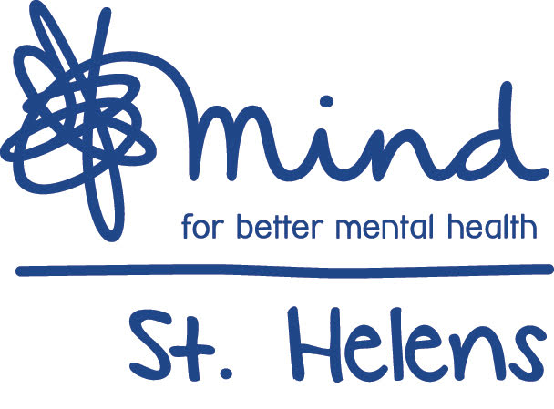
Telephone Counselling

Welcome to St. Helens Mind’s
Telephone Counselling Service.

This service has been established in direct response to those who have been affected by the Covid 19 epidemic, leading to anxiety, loneliness, depression and issues that arise during these difficult times.

However, we can accept referrals from any adult aged18+ in the St.Helens Borough to support people begin to seek solutions within their own capacity and reconstruct their lives following the effect of life altering events such as loss, bereavement, divorce, abuse, domestic violence and child hood issues.

We provide a professional and confidential service that is free of charge.
The service and can be accessed by self-referral as well as health and social care agencies.

We offer one-to-one counselling sessions on the telephone, where you can feel relaxed and able to discuss concerns freely.

We aim to provide a service that meets your varied needs and so aim to provide the service during the daytime and evenings.

The waiting time for your first appoint with St.Helens Mind Counselling Service is kept to a minimum.

Although we aim to provide a comprehensive counselling service there are areas that we cannot cover;

- Clients who are involved or have a court case pending.
- Perpetrators of sexual abuse.
- Clients who are under the influence of alcohol / drugs or high doses of medication.
- Clients receiving treatment from Psychologist / psychiatrist without approval.

Please complete the referral form and return it to us via email:

Email: sue@sthelensmind.org.uk

Telephone Counselling  Referral Form | Date Referred: Office use only
 | Client Ref:

Name: |  |  | D.O.B:
Address:

Postcode: | Can we contact you by post? Yes ☐ No ☐
Email:

Phone number home: |  | Phone number mobile: |  | Can we leave a message:  Yes ☐ No ☐

What is your availability? All appointments are on the hour.

Please put an X in the box to indicate the times the person you or the person you are referring can be available
 | 10 | 11 | 12 | 1 | 2 | 3 | 4 | 5 | 6 | 7
MON
TUE
WED
THUR
FRI
SAT

Referred by:

How did you hear about this counselling service?

GP details:

Reason For Referral:

Additional Relevant Information:

Do you consider yourself to have a disability, excluding mental health problems. If so, please specify:

Please describe your ethnicity:
- White British | ☐ | 19. White Irish | ☐
- White Other | ☐ | 10. Mixed White & Black African | ☐
- Mixed White & Asian | ☐ | 11. Mixed Other | ☐
- Black Caribbean  (Black or Black British) | ☐ | 12. Black African  (Black or Black British) | ☐
- Other (Black or Black British) | ☐ | 13. Indian (Asian or Asian British) | ☐
- Pakistani (Asian or Asian British) | ☐ | 14. Bangladeshi (Asian or Asian  British) | ☐
- Other (Asian or Asian British) | ☐ | 15. Chinese | ☐
- Chinese (Other) | ☐

For St.Helens Mind Use Only:
Assigned To:
Date Of First Appointment:
Date accepted:

St Helens Mind is registered in England and Wales
as a Registered Charit1y No. 143292 and Company Limited by Guarantee No. 7659498

